

**MAHARASHTRA STATE BOARD OF TECHNICAL EDUCATION, MUMBAI**

A Project Report on

Face Recognition using Haar Cascade and LBPH Algorithm

Submitted in partial fulfillment for the award of

Diploma in Computer Engineering

By

Aayush Shashikant Jadhav

Pranav Sudhakar Babrekar

Nayan Bhaskar Bhadane

Khushal Hirchand Patil



**DEPARTMENT OF COMPUTER ENGINEERING**

**S. S. V. P. S’s Bapusaheb Shivajirao Deore Polytechnic, Dhule**

**(Institute Code: 0059)**

**2022-2023**

A Project Report on

Face Recognition using Haar Cascade and LBPH Algorithm

Submitted in partial fulfillment for the award of

Diploma in Computer Engineering

By

Aayush Shashikant Jadhav

Pranav Sudhakar Babrekar

Nayan Bhaskar Bhadane

Khushal Hirchand Patil

**Guided by**

**Mr. C. P. Bhamare**



**DEPARTMENT OF COMPUTER ENGINEERING**

**S. S. V. P. S's Bapusaheb Shivajirao Deore Polytechnic, Dhule**

**(Institute Code: 0059)**

**2022-2023**

**MAHARASHTRA STATE BOARD OF TECHNICAL EDUCATION, MUMBAI**

**S. S. V. P. S's Bapusaheb Shivajirao Deore Polytechnic, Dhule**

**DEPARTMENT OF COMPUTER ENGINEERING**

**CERTIFICATE**

This is to certify that, Mr. **Aayush Shashikant Jadhav** From **S. S. V. P. S’s B. S. Deore Polytechnic, Dhule** having Enrollment No **2000590057** has completed project of final year having title “**Face Recognition using Haar Cascade and LBPH Algorithm”** during the academic year 2022-2023. The project is completed in a group consisting of **4** persons under the guidance of the Faculty Guide.

**Place :** Dhule **Examination Seat No.:** 378823

**Date :**

**Signature:** **Signature:**

**Name :** Mr. C. P. Bhamare **Name :** Mrs. S. H. Patil

**Guide**  **H.O.D.**

**Signature:** **Signature:**

**Name :**  **Name :** Prof. P B. Kachave

**External**  **Principal**

Seal of

Institute

**MAHARASHTRA STATE BOARD OF TECHNICAL EDUCATION, MUMBAI**

**S. S. V. P. S's Bapusaheb Shivajirao Deore Polytechnic, Dhule**

**DEPARTMENT OF COMPUTER ENGINEERING**

**CERTIFICATE**

This is to certify that, Mr. **Pranav Sudhakar Babrekar** From **S. S. V. P. S’s B. S. Deore Polytechnic, Dhule** having Enrollment No **2000590061** has completed project of final year having title “**Face Recognition using Haar Cascade and LBPH Algorithm”** during the academic year 2022-2023. The project is completed in a group consisting of **4** persons under the guidance of the Faculty Guide.

**Place :** Dhule **Examination Seat No.:** 378826

**Date :**

**Signature:** **Signature:**

**Name :** Mr. C. P. Bhamare **Name :** Mrs. S. H. Patil

**Guide** **H.O.D.**

**Signature:**  **Signature:**

**Name :**   **Name :** Prof. P B. Kachave

**External**  **Principal**

Seal of

Institute

**MAHARASHTRA STATE BOARD OF TECHNICAL EDUCATION, MUMBAI**

**S. S. V. P. S's Bapusaheb Shivajirao Deore Polytechnic, Dhule**

**DEPARTMENT OF COMPUTER ENGINEERING**

**CERTIFICATE**

This is to certify that, Mr. **Nayan Bhaskar Bhadane** From **S. S. V. P. S’s B. S. Deore Polytechnic, Dhule** having Enrollment No **2000590064** has completed project of final year having title “**Face Recognition using Haar Cascade and LBPH Algorithm”** during the academic year 2022-2023. The project is completed in a group consisting of **4** persons under the guidance of the Faculty Guide.

**Place :** Dhule **Examination Seat No.:** 378829

**Date :**

**Signature:** **Signature:**

**Name :** Mr. C. P. Bhamare **Name :** Mrs. S. H. Patil

**Guide**   **H.O.D.**

**Signature:** **Signature:**

**Name :**  **Name :** Prof. P B. Kachave

**External**  **Principal**

Seal of

Institute

**MAHARASHTRA STATE BOARD OF TECHNICAL EDUCATION, MUMBAI**

**S. S. V. P. S's Bapusaheb Shivajirao Deore Polytechnic, Dhule**

**DEPARTMENT OF COMPUTER ENGINEERING**

**CERTIFICATE**

This is to certify that, Mr. **Khushal Hirchand Patil** From **S. S. V. P. S’s B. S. Deore Polytechnic, Dhule** having Enrollment No **2000590097** has completed project of final year having title “**Face Recognition using Haar Cascade and LBPH Algorithm”** during the academic year 2022-2023. The project is completed in a group consisting of **4** persons under the guidance of the Faculty Guide.

**Place :** Dhule **Examination Seat No.:** 378857

**Date :**

**Signature:** **Signature:**

**Name :** Mr. C. P. Bhamare **Name :** Mrs. S. H. Patil

**Guide** **H.O.D.**

**Signature:** **Signature:**

**Name :**  **Name :** Prof. P B. Kachave

**External**  **Principal**

Seal of

Institute

**Acknowledgement**

We wish to express our heartfelt gratitude to our project guide, Mr. C. P. Bhamare, who gave us the courage to undertake the project and provided us with valuable guidance at every step. He stood behind us in all the difficulties we faced during the development of the project.

We would also like to express our sincere thanks to our HOD, Mrs. S.H. Patil, and all the staff members of the Computer Engineering Department for their support in the preparation of this project. We are also grateful to our friends for their unwavering support.

Finally, we would like to express our deepest gratitude to our families for always being there for us when we needed them the most.

Aayush Shashikant Jadhav

Pranav Sudhakar Babrekar

Nayan Bhaskar Bhadane

Khushal Hirchand Patil

**Content Page**

|  |  |  |
| --- | --- | --- |
| Chapter No. | Title | Page No. |
|  | Abstract | i |
|  | List of Figures | ii |
| 1 | Introduction | 01 |
| 2 | Literature Survey | 03 |
| 3 | Scope of the project | 09 |
| 4 | Methodology | 10 |
| 5 | Details of designs, working and processes | 18 |
| 6 | Results and applications | 25 |
| 7 | Conclusion and future scope | 37 |
|  | References and Bibliography | 38 |

**Abstract**

The attendance system is used to track and monitor whether a student attends a class. There are different types of attendance systems like Biometric-based, RFID based, face recognition based and old Register-based attendance system. Out of them all, a Face recognition-based attendance system is more secure and time-saving.

The system uses Haar Cascade for face detection and LBPH algorithm for face recognition. The system is evaluated based on scenarios like face recognition rate, false-positive rate, and false-positive rate with and without applying the threshold while detecting unknown persons. The system achieved a face recognition rate of 77% for students, with a false-positive rate of 28%. The system is able to recognize students even if they are wearing glasses or have a beard.

The proposed system is developed for faculties to mark attendance at real time using Haa Cascade algorithm for face detection and Local Binary Pattern Histogram algorithm for face recognition because it is secure, time-saving, and effective solution for tracking and monitoring student attendance. This system has the potential to replace traditional attendance systems and improve the accuracy and efficiency of attendance tracking in educational institutions.

**List of Figures**

|  |  |  |
| --- | --- | --- |
| **Fig. No.** | **Figure Name** | **Page.No.** |
| 2.1 | Haar Cascade Algorithm Flowchart | 06 |
| 2.2 | LBPH Algorithm Flowchart | 07 |
| 4.1 | System Flowchart | 10 |
| 4.2 | Haarcascade features extraction | 12 |
| 4.3 | LBP Operation | 15 |
| 4.4 | Converting Input image to LPBH image | 15 |
| 4.5 | Extracting Histogram | 15 |
| 4.6 | Combining Step 2 and Step 3 | 16 |
| 4.7 | XML File | 16 |
| 4.8 | Face Alignment and Feature Extraction | 17 |
| 5.1 | Proposed System | 18 |
| 5.2 | Database Design | 20 |
| 5.3 | Admin Module Flowchart | 21 |
| 5.4 | Faculty Module Flowchart | 23 |
| 6.1 | Login Screen | 25 |
| 6.2 | Admin Home Screen | 26 |
| 6.3 | Student Details | 27 |
| 6.4 | Capturing Student Images | 28 |
| 6.5 | Manage Users | 29 |
| 6.6 | Training Dataset Images | 30 |
| 6.7 | Faculty Home Screen | 31 |
| 6.8 | Take Attendance Screen | 32 |
| 6.9 | Attendance Marking | 33 |
| 6.10 | View Attendance | 34 |
| 6.11 | Searched Attendance History | 35 |
| 6.12 | Attendance PDF report | 36 |

**Chapter 1**

**Introduction**

* 1. **Student Attendance**

Recording student attendance is a crucial administrative task that needs to be done at the beginning of each class. However, it can be time-consuming and challenging to manage, with traditional attendance books being difficult to read and prone to errors in marking attendance.

For educational institutions like schools, colleges, and classes, attendance is one of the most important issues as it plays a role in evaluating a student's final grade. Properly recording attendance is essential for effective planning, management, and functioning of any organization, be it educational or commercial.

Attendance is a measure of the number of students present in a class or college, and it helps in keeping track of their presence and absence. Regular attendance is a significant responsibility for students at all grade levels, as studies have shown that it is correlated with success in school. Attending classes regularly ensures that the academic learning process is not disrupted, less time is spent on make-up assignments, and students benefit from participating and interacting with others in class. Classroom and school activities provide valuable lessons that cannot be replaced by individual study.

**1.2 Face Detection & Face Recognition**

For identification of a person, the most important part of the human body is the face. Face detection is the ability of a computer system to identify and locate human faces in images or video. It is a key component of many applications, including security systems, video surveillance, and facial recognition.

Face detection algorithms use a variety of techniques, such as machine learning and image processing, to analyze an image and locate regions that are likely to contain faces. These regions are then analyzed further to determine if they do in fact contain a face, and if so, to identify the location and size of the face.

Face recognition is a type of biometric identification that takes all of a person's facial features and stores them as a unique face print in order to uniquely identify the person. Because of its application and range, Biometric face recognition has gained quite some popularity among researchers. Also, its contact free procedure that is why it outsmarts all other recognitions like fingerprint, iris print and palm print. Face recognition technology is also able to detect a person from far away, without coming in physical contact with anyone.

Today, a lot of the facial recognition systems perform very well with the limited faces in the frame. Moreover, these types of methodologies have been tested under very limited and very controlled lighting conditions, very proper face poses and usually non-blurry images. Face recognition-based attendance systems will be based on the technology of face recognition and it will be very useful for teachers as it will provide a very convenient way of marking attendance of the students for teachers. Using the LBPH algorithm for face recognition and the Haar Cascade algorithms for face detection, this attendance-based system can be used by teachers for their convenience.

**1.3 Face Recognition in Attendance System**

Taking attendance every day helps determine the average percentage of students’ presence throughout the year and the dropout’s rate. In traditional attendance system is a manual entry for the faculty. Here the attendance will be carried out in the hand written registers. Maintaining the records for the faculty is a tedious job.

The purpose of the student attendance system using face recognition is to ease the attendance process which consumes lot of time and efforts, it is a convenient and easy way for students and teacher.

The system will capture the images of the students by using Haar Cascade algorithm as it contains predefined features of a face provided by OpenCV library and mark the attendance in the database by using xml file of histograms of dataset generated through applying LBPH face recognition algorithm. This way the class-teacher will get their attendance marked without actually spending time in traditional attendance marking.

**Chapter 2**

**Literature Survey**

We have surveyed four research papers and studied existing student’s attendance system.

**2.1 Literature Survey**

**Ononiwu G. Chiagozie & Okorafor G. Nwaji [2]** in this paper Radio-frequency identification (RFID) is a technology that uses radio waves to transfer data from an electronic tag, called RFID tag or label, attached to an object, through a reader for the purpose of identifying and tracking the object. RFID technology which is a matured technology that has been widely deployed by varxious organizations as part of their automation systems. In this study, an RFID based system has been built in order to produce a time-attendance management system.

This system consists of two main parts which include: the hardware and the software. The hardware consists of the motor unit and the RFID reader. The RFID reader, which is a low-frequency reader (125 kHz), is connected to the host computer via a serial to USB converter cable. The Time-Attendance System GUI was developed using visual basic.Net. The Time-Attendance Management System provides the functionalities of the overall system such as displaying live ID tags transactions, registering ID, deleting ID, recording attendance and other minor functions. This interface was installed in the host computer.

In this approach, the proposed RFID tag uses energy from the tag reader. The problem with this approach is that an unknown person can make use of a valid ID card and enter the University.

**O. Shoewu, Ph.D. & O.A. Idowu, B.Sc. [3]** in this paper, the development of an attendance management system using biometrics is proposed. Managing student attendance during lecture periods has become a difficult challenge. The ability to compute the attendance percentage becomes a major task as manual computation produces errors, and also wastes a lot of time. For the stated reason, an efficient attendance management system using biometrics is designed. This system takes attendance electronically with the help of a finger print device and the records of the attendance are stored in a database. Attendance is marked after student identification.

For student identification, a biometric (fingerprint) identification-based system is used. This process however, eliminates the need for stationary materials and personnel for the keeping of records. Eighty candidates were used to test the system and success rate of 94% was recorded. The manual attendance system average execution time for eighty students was 17.83 seconds while it was 3.79 seconds for the automatic attendance management system using biometrics. The results showed improved performance over manual attendance management system. Attendance is marked after student identification.

The problem with this method is that for attendance students should go to the place where this hardware device is located or pass the hardware device around the students during class which can be a distraction to the students.

**Jomon Joseph1, K. P. Zacharia [4]** in this paper authors proposed a face recognition-based attendance system based on Eigenface recognition. The current manual attendance marking methods are monotonous and time-consuming and can be easily manipulated. Hence, this paper proposes a solution to tackle all these issues. The proposed system consists of a high-resolution digital camera embedded on a micro-controller-based motor system that enables it to rotate in left and right directions. The images obtained by the camera are sent to a computer programmed system for further analysis using MATLAB's Image Acquisition Toolbox and Image Processing Toolbox. The obtained images are then compared with a set of reference images of each of the employees or students and mark the corresponding attendance.

The system also provides for continuous monitoring of the classroom by an operator if needed. The proposed system uses the eigenface approach for face recognition which was introduced by Kirby and Sirovich in 1988 at Brown University. The method works by analyzing face images and computing eigenface which are faces composed of eigenvectors. The comparison of eigenface is used to identify the presence of a face and its identity. This paper discusses the implementation of the proposed system using a PIC micro-controller along with a servo motor mechanism. The system can be used in applications such as robotics, CNC machinery or automated manufacturing.

The problem with this approach is that this method is very sensitive to face background, head orientations and it doesn’t recognize the face of a person if the person is wearing glasses or a grown beard, etc.

**B. T. Chinimilli, Anjali T, A. Kotturi, V. R. Kaipu, J. V. Mandapati [1]** This paper presents a proposal for a face recognition-based attendance system using the Haar Cascade algorithm for face detection and the Local Binary Pattern Histogram (LBPH) algorithm for face recognition. The system aims to provide a secure and time-saving method of tracking and monitoring attendance while also minimizing the false-positive rate in detecting unknown persons. This system's Graphical User Interface (GUI) was created using the Python module Tkinter.

The research compares this system's performance against other Euclidean distance-based algorithms like Eigenfaces and Fisherfaces, with LBPH algorithm outperforming the others. The face recognition rate achieved by this system for known students is 77%, with a false-positive rate of 28%. This system can recognize students even if they are wearing glasses or have grown a beard. This system also detects and saves images of unknown persons in the class whose information is not in the database, with a face recognition rate of nearly 60%. The research evaluates the false-positive rate with and without applying a threshold in detecting unknown persons, achieving a false-positive rate of 14% and 30%, respectively.

This system provides functionalities such as taking images of students, training images in the database, and tracking people entering the class. The paper concludes by stating that this system's robustness against grayscale transformations and sensitivity to face background or head orientation makes it an effective solution for attendance management.

Following algorithms of this system are implemented on the proposed system.

**Haarcascade Algorithm for Face Detection**

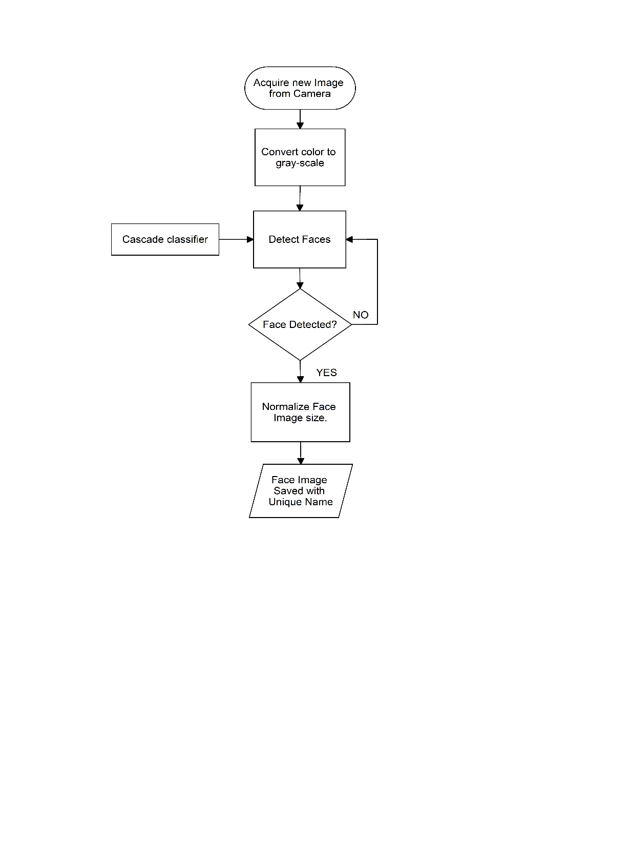

Fig. 2.1 – Haar Cascade Algorithm Flowchart

Haar Cascade works by detecting features in an image that are similar to pre-defined features of a face, such as the eyes, nose, and mouth. These features are learned through a training process, where the algorithm is shown a large number of positive and negative images. Positive images contain faces, while negative images do not.

During training, the algorithm extracts feature from the images and uses them to create a set of classifiers. Each classifier represents a specific facial feature, and multiple classifiers are combined to form a "cascade" of classifiers. This cascade is then used to detect faces in new images.

To detect faces in an image using Haar Cascade, the algorithm slides a "window" over the image and applies each classifier in the cascade to the window. If the window matches the feature represented by a classifier, it is passed on to the next classifier in the cascade. If the window fails to match any classifier, it is rejected as a non-face region.

Haar Cascade is a robust and efficient algorithm for face detection, and it has been successfully applied in many real-world scenarios.

**Local Binary Pattern Histogram Algorithm for Face Recognition**

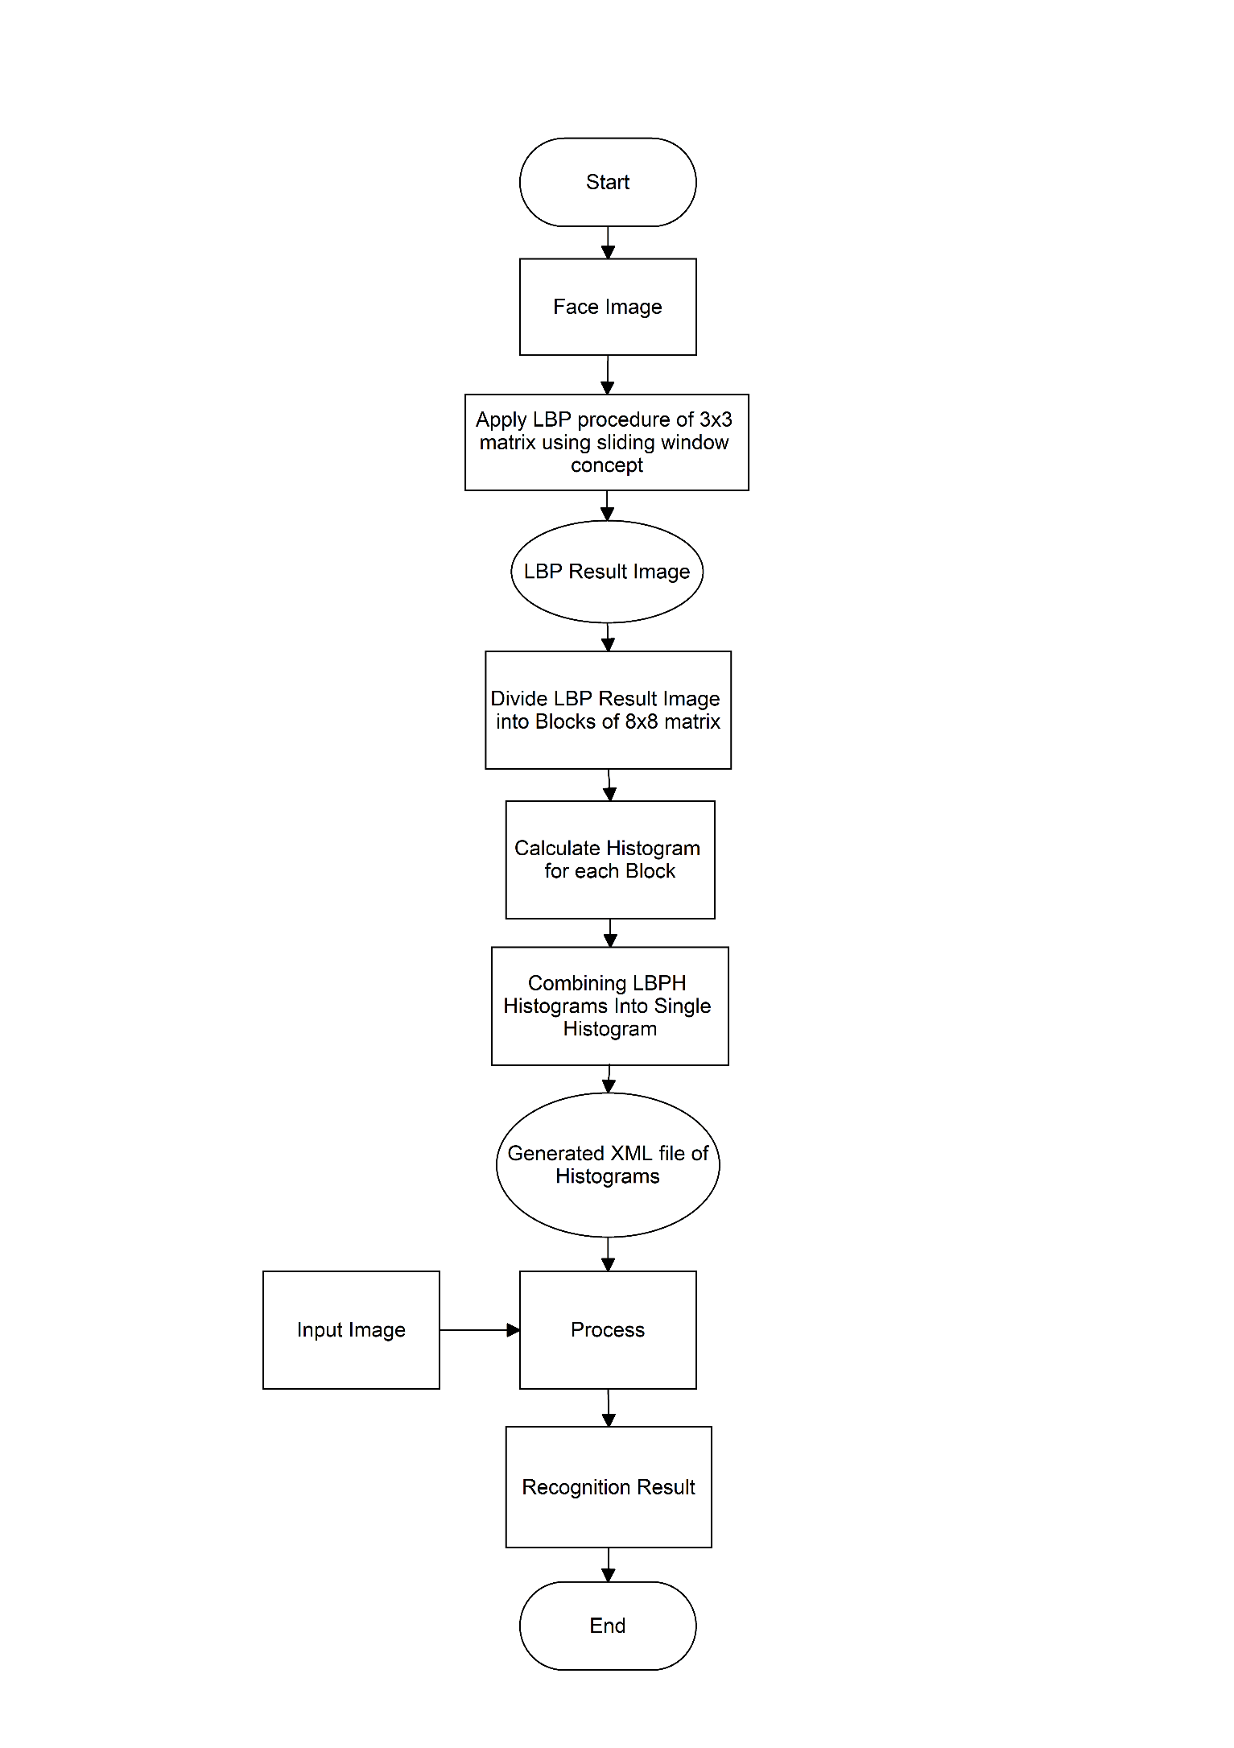

Fig. 2.2 – LBPH Algorithm Flowchart

LBPH (Local Binary Patterns Histograms) is a face recognition method that is commonly used in computer vision applications. It is a texture-based approach that considers the local binary patterns of an image to create a histogram of the image's features. LBPH is able to capture information about the local patterns and textures of an image, which makes it robust to variations in lighting and pose.

To use LBPH for face recognition, the algorithm first divides the image into small regions or "cells". For each cell, it computes the local binary patterns of the pixels. Local binary patterns are a way of describing the texture of an image by comparing the intensity of each pixel to its surrounding pixels. If the surrounding pixels have a higher intensity value than the central pixel, it is assigned a 1, otherwise it is assigned a 0. This creates a binary pattern that represents the texture of that area of the image.

Once the local binary patterns have been computed for each cell, a histogram is created that counts the occurrences of each binary pattern within the cell. The histograms are then concatenated to form a single feature vector that represents the entire image. This feature vector can then be compared to other feature vectors to determine the similarity between images and perform face recognition then mark attendance.

**2.2 Problem Definition**

This proposed automated Attendance system is based on Haar Cascade for face detection and the LBPH algorithm for face recognition and attendance of the respective student will be marked automatically on table present in database.

**Chapter 3**

**Scope of the project**

The scope of the project to reduce the time of the teacher as well as student which they wasted by doing traditional attendance and eliminate proxy attendance. This product is tested for Department of Computer Engineering of S.S.V.P. S’s B. S. Deore Polytechnic, Dhule.

**3.1. User Requirements**

* Taking and tracking student attendance by facial recognition in specific time.
* It should not be sensitive to face background, head orientations and it should recognize a person’s face even if he grows a beard or wears glasses, etc.
* Compute the total attendance based on detected faces.
* The lecturer can retake attendance of the students which may have marked ‘absent’.

**3.2 System Requirements**

1. Software Requirements Platform:
   * + Operating System: Windows OS
     + Platform: Visual Studio Code
     + Programming Language: Python
     + Libraries:
2. OpenCV - OpenCV is a library of programming functions mainly aimed at real-time computer vision.
3. NumPy - NumPy is a library for adding support for large, multi-dimensional arrays and matrices.
4. Tkinter - Tkinter is the standard GUI library for Python.
5. ReportLab - ReportLab is a powerful PDF generation library for Python that allows you to create complex PDF documents with ease.
6. Hardware Requirements:
   * + Processor: Intel i3 Processor Core
     + Hard Disk: 500 GB (min)
     + RAM: 2 GB or higher
     + Camera: Webcam

**Chapter 4**

**Methodology**

**4.1 System Diagram**

Fig. 4.1 - System Flowchart

**4.2 Algorithms**

1. **Detection And Recognition**

* Face Detection: It has the objective of finding the faces (location and size) in an image and extract them to be used by the face recognition algorithm.
* Face Recognition: With the facial images already extracted, cropped, resized and usually converted to grayscale, the face recognition algorithm is responsible for finding characteristics which best describe the image.

1. **Haar Cascade Algorithm**

The HAAR cascade is a machine learning approach where a cascade function is trained from a lot of positive and negative images. Positive images are those images that consist of faces, and negative images are without faces. In face detection, image features are treated as numerical information extracted from the pictures that can distinguish one image from another.

We apply every feature of the algorithm on all the training images. Every image is given equal weight at the starting. It founds the best threshold which will categorize the faces to positive and negative. There may be errors and misclassifications. We select the features with a minimum error rate, which means these are the features that best classifies the face and non-face images.

All possible sizes and locations of each kernel are used to calculate the plenty of features.

OpenCV provides the trainer as well as the detector. We can train the classifier for any object like cars, planes, and buildings by using the OpenCV. There are two primary states of the cascade image classifier first one is training and the other is detection.

OpenCV provides two applications to train cascade classifier opencv _haartraining and opencv traincascade. These two applications store the classifier in the different file format.

For training, we need a set of samples. There are two types of samples:

* Negative sample: It is related to non-object images.
* Positive samples: It is a related image with detect objects.

A set of negative samples must be prepared manually, whereas the collection of positive samples is created using the opencv_createsamples utility.

**Negative Sample**

Negative samples are taken from arbitrary images. Negative samples are added in a text file. Each line of the file contains an image filename (relative to the directory of the description file) of the negative sample. This file must be created manually. Defined images may be of different sizes.

**Positive Sample**

Positive samples are created by opencv_createsamples utility. These samples can be created from a single image with an object or from an earlier collection. It is important to remember that we require a large dataset of positive samples before you give it to the mentioned utility because it only applies the perspective transformation.

Here we will discuss detection. OpenCV already contains various pre-trained classifiers for face, eyes, smile, etc. Let's understand the following steps:

**Step – 1**

First, we need to load the necessary XML classifiers and load input images (or video) in grayscale mode.

**Step -2**

After converting the image into grayscale, we can do the image manipulation where the image can be resized, cropped, blurred, and sharpen if required. The next step is image segmentation; identify the multiple objects in the single image, so the classifier quickly detects the objects and faces in the picture.

**Step - 3**

The haar-Like feature algorithm is used to find the location of the human faces in frame or image. All the Human faces have some common universal properties of faces like the eye region is darker than its neighbor's pixels and nose region is brighter than the eye region.

**Step -4**

In this step, we extract the features from the image, with the help of edge detection, line detection, and center detection. Then provide the coordinate of x, y, w, h, which makes a rectangle box in the picture to show the location of the face. It can make a rectangle box in the desired area where it detects the face.

Fig. 4.2 - Haar Cascade Features Extraction

## **Introduction of Local Binary Pattern Histogram (LBPH)**

Local Binary Pattern Histogram algorithm is a simple approach that labels the pixels of the image thresholding the neighborhood of each pixel. In other words, LBPH summarizes the local structure in an image by comparing each pixel with its neighbors and the result is converted into a binary number. It was first defined in 1994 (LBP) and since that time it has been found to be a powerful algorithm for texture classification.

This algorithm is generally focused on extracting local features from images. The basic idea is not to look at the whole image as a high-dimension vector; it only focuses on the local features of an object.

**Steps of the algorithm:**

**1. Selecting the Parameters:** The LBPH accepts the four parameters:

1. **Radius:** It represents the radius around the central pixel. It is usually set to 1. It is used to build the circular local binary pattern.
2. **Neighbors:** The number of sample points to build the circular binary pattern.
3. **Grid X:** The number of cells in the horizontal direction. The more cells and finer grid represent, the higher dimensionality of the resulting feature vector.
4. **Grid Y:** The number of cells in the vertical direction. The more cells and finer grid represent, the higher dimensionality of the resulting feature vector.

**2. Training the Algorithm:**

The first step is to train the algorithm. It requires a dataset with the facial images of the person that we want to recognize. A unique ID (it may be a number or name of the person) should provide with each image. Then the algorithm uses this information to recognize an input image and give you the output. An Image of particular person must have the same ID. Let's understand the LBPH computational in the next step.

**3. Performing LBP operation:**

In this step, LBP computation is used to create an intermediate image that describes the original image in a specific way through highlighting the facial characteristic. The parameters **radius** and **neighbors** are used in the concept of sliding window.

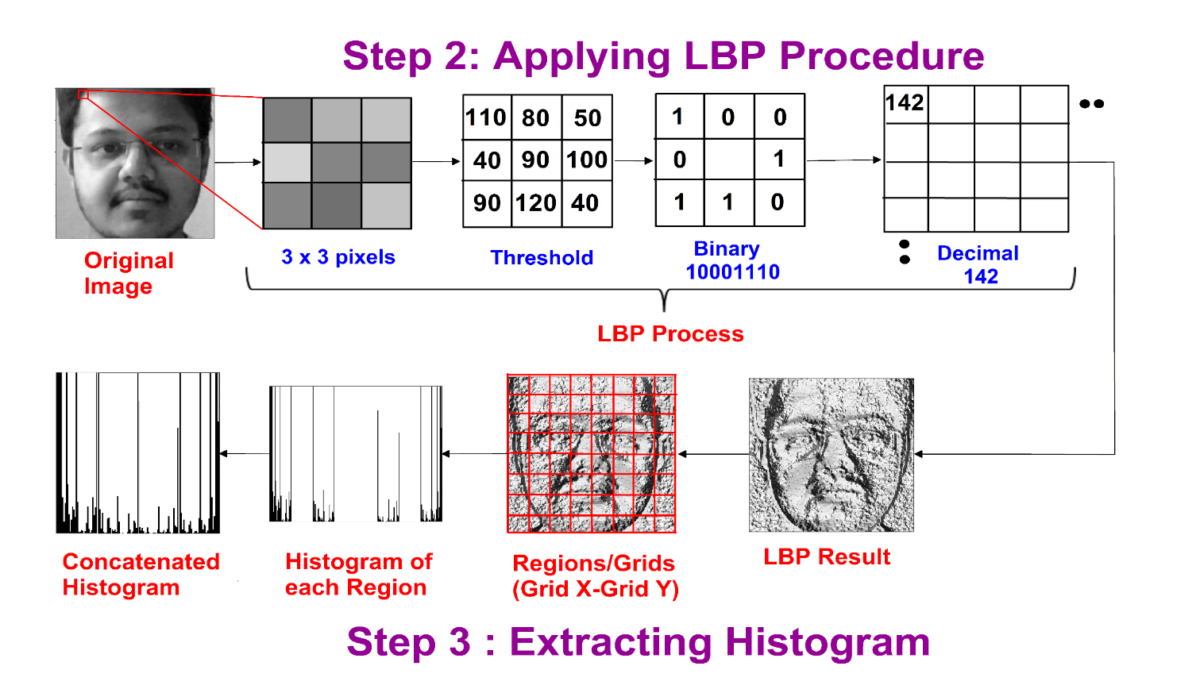

Fig. 4.3 - LBP Operation

To understand in a more specific way, let's break it into several small steps:

* Suppose the input facial image is grayscale.
* We can get part of this image as a window of 3x3 pixels.
* We can use the 3x3 matrix containing the intensity of each pixel (0-255).
* Then, we need to take the central value of the matrix to be used as a threshold.
* This value will be used to define the new values from the 8 neighbors.
* For every neighbor of the central value (threshold), we set a new binary value. The value 1 is set for equal or higher than the threshold and 0 for values lower than the threshold.
* Now the matrix will consist of only binary values (skip the central value). We need to take care of each binary value from each position from the matrix line by line into new binary values (10001101). There are other approaches to concatenate the binary values (clockwise direction), but the final result will be the same.
* We convert this binary value to decimal value and set it to the central value of the matrix, which is a pixel from the original image.
* After completing the LBP procedure, we get the new image, which represents better characteristics of the original image.

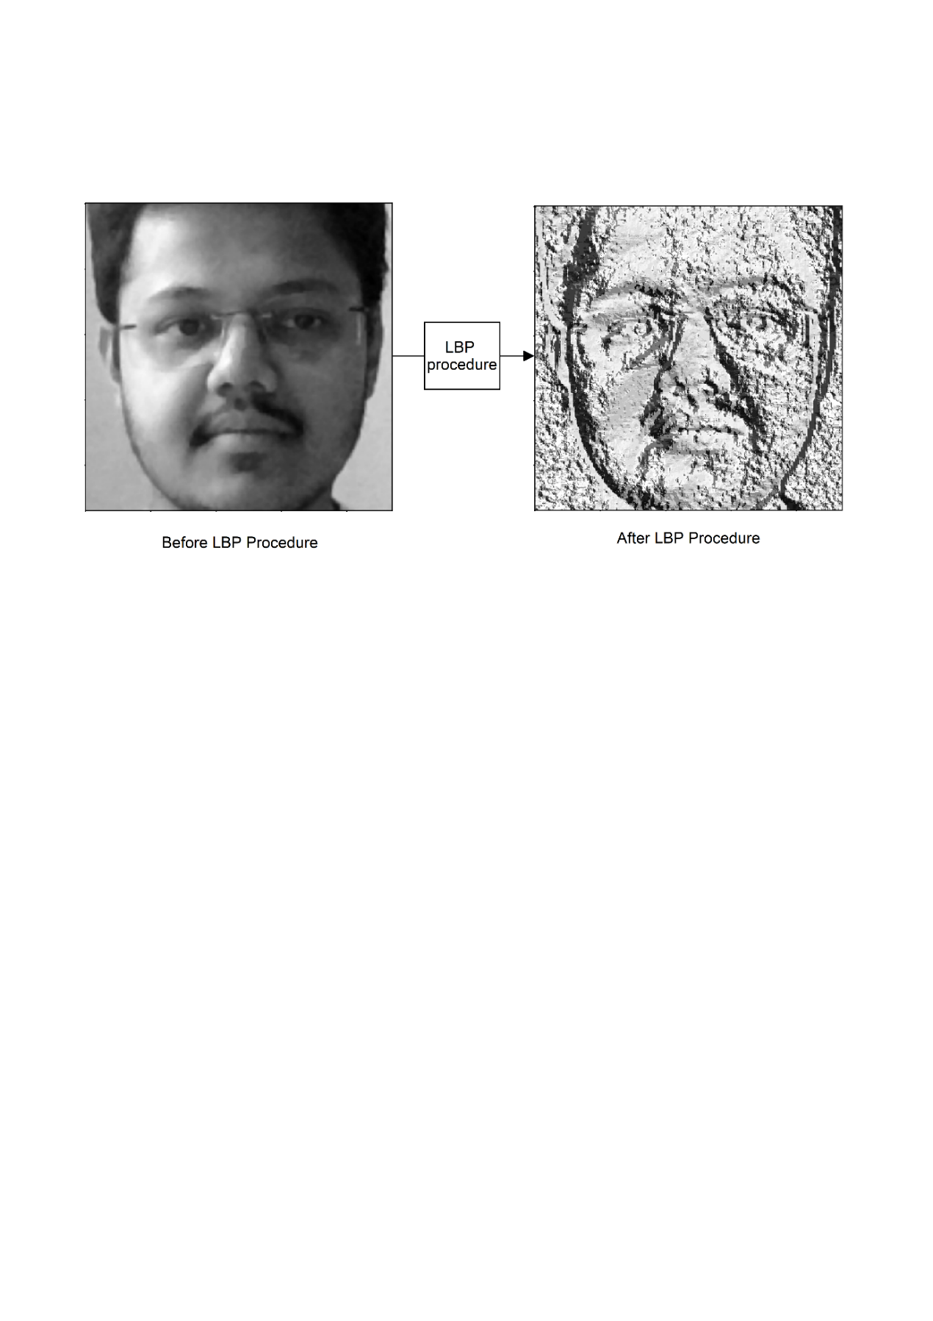

Fig. 4.4 - Converting Input image to LPBH image

**4. Extracting the Histograms from the image:**

The image is generated in the last step, we can use the **Grid X** and **Grid Y** parameters to divide the image into multiple grids, let's consider the following image:

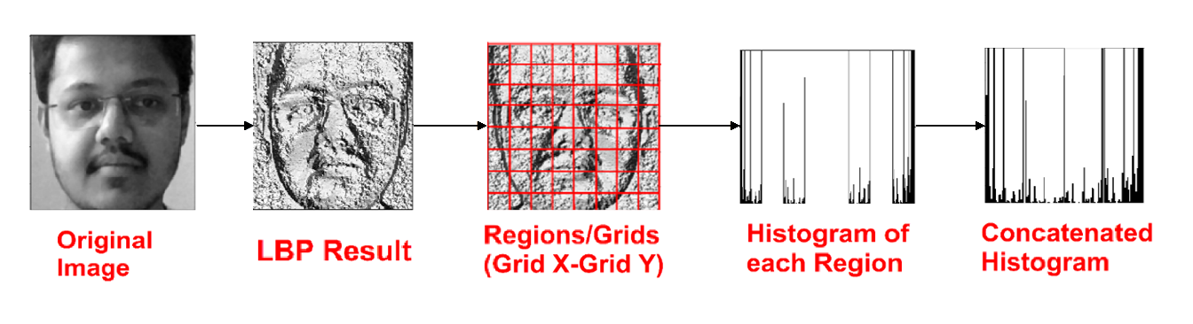

Fig. 4.5 - Extracting Histogram

* We have an image in grayscale; each histogram (from each grid) will contain only 256 positions representing the occurrence of each pixel intensity.
* It is required to create a new bigger histogram by concatenating each histogram.



Fig. 4.6 – Combining Step 2 and Step 3

After Completing Step 2 and Step 3 is completed an XML file will be generated as output as shown in (Fig. 4.7)

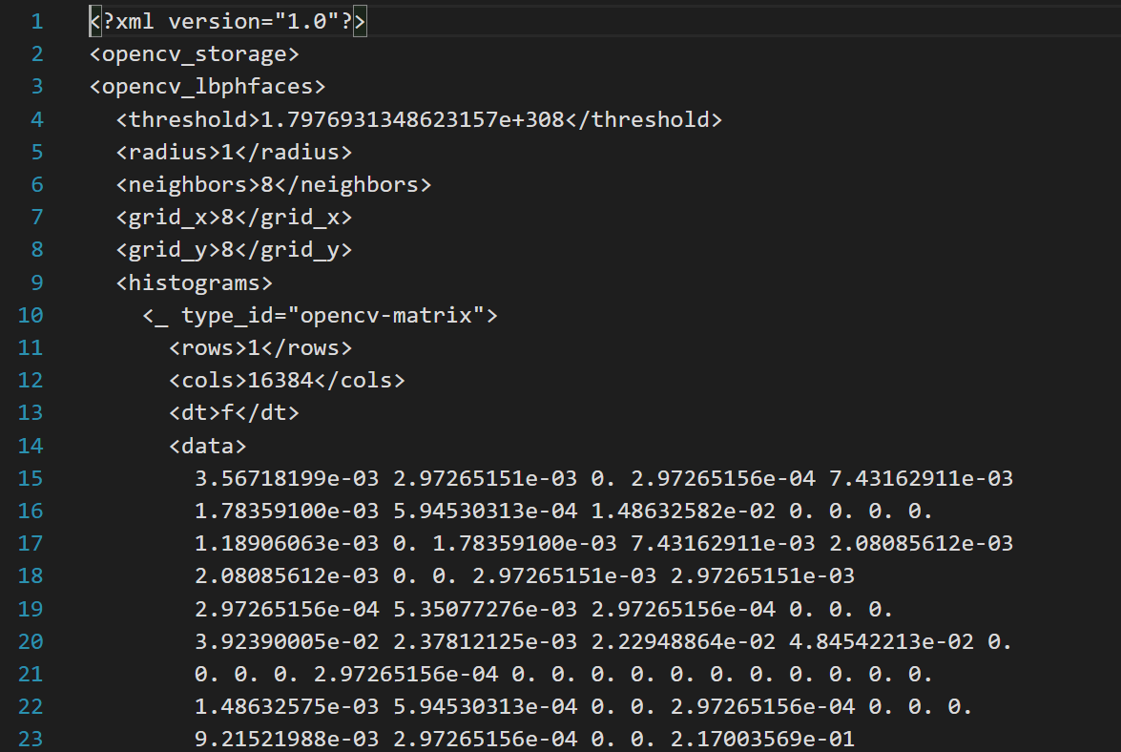

Fig. 4.7 – XML file

**5. Performing face recognition:**

Now, the algorithm is well trained. The extracted histogram is used to represent each image from the training dataset. For the new image, we perform steps again and create a new histogram. To find the image that matches the given image, we just need to match two histograms and return the image with the closest histogram.

There are various approaches to compare the histograms (calculate the distance between two histograms), for example: **Euclidean distance, chi-square, absolute value,** etc. We can use the Euclidean distance based on the following formula:

D= $\sqrt{\sum_{i=1}^{n}{(hist 1_{i}-hist 2_{i})^{2} } }$

The algorithm will return ID as an output from the image with the closest histogram. The algorithm should also return the calculated distance that can be called **confidence** measurement. If the confidence is lower than the threshold value, that means the algorithm has successfully recognized the face.

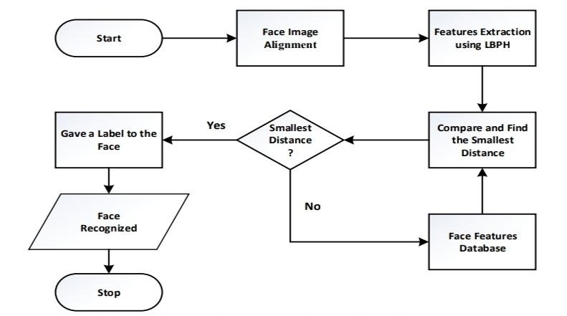

Fig. 4.8 - Face Alignment and Feature Extraction

**Chapter 5**

**Details of Designs, Working and Processes**

**5.1 Proposed System**

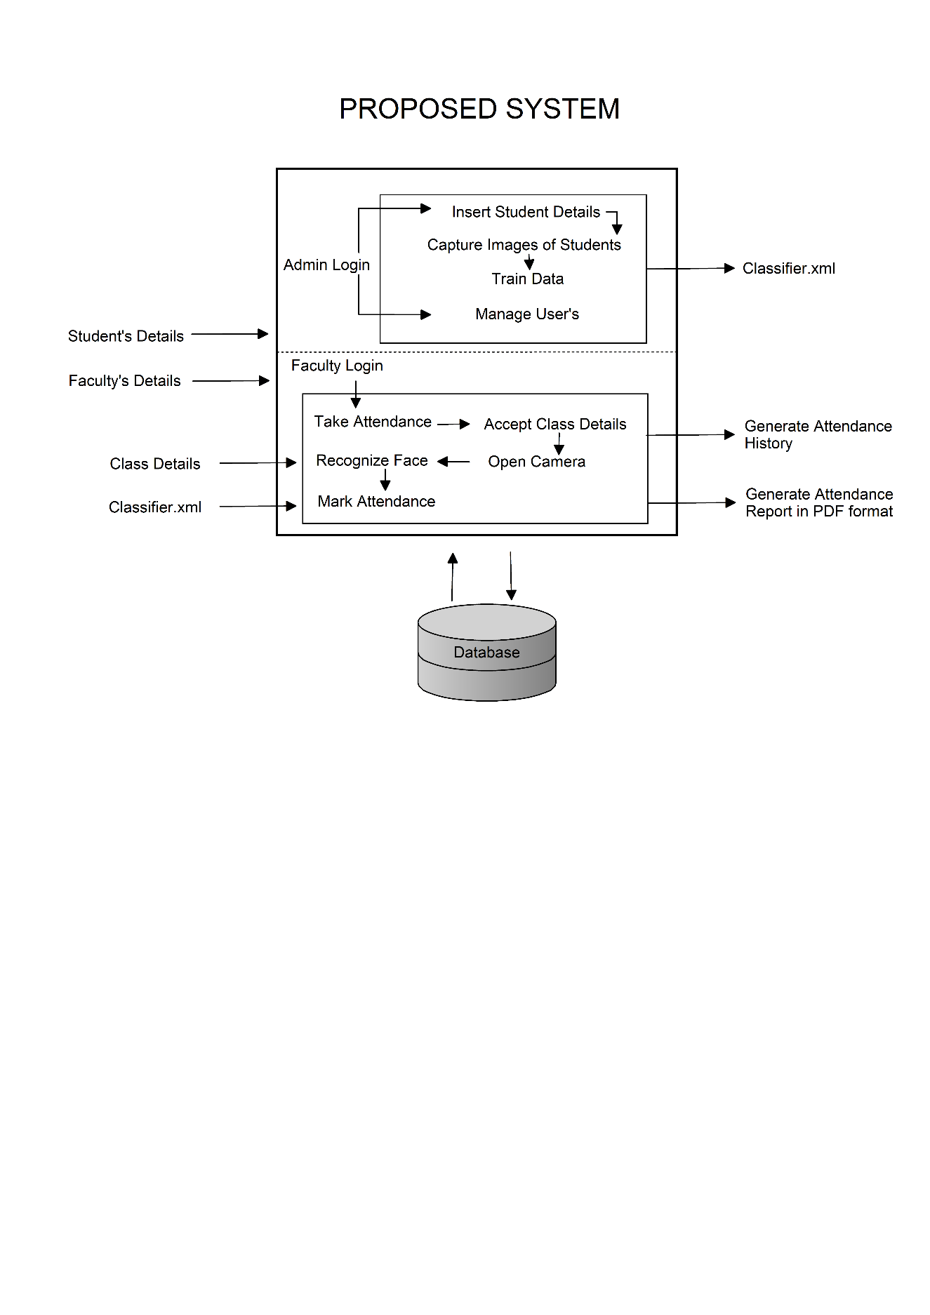

Fig. 5.1 – Proposed System

**5.2 Modules**

1. Admin and Faculty Login –

Admin can Login in Admin Dashboard and Faculty can Login in Faculty Dashboard through here using their existing credentials.

1. Manage Users –

Admin can create account for the Faculty to Login.

Admin can remove Faculty account.

1. Student Details –

Admin can insert data of new student or update the data of the existing student or can delete the record of the existing student.

After saving the data admin should select student information and need to Capture 100 photos of student using webcam and store it for recognition.

Also, admin can search and check if the student’s data is stored or not by selecting his Branch, Year and Division to minimize duplication of student record.

After saving data of all student’s admin need to Train Data (creating .xml file by applying LBPH algorithm on students captured photo’s) from Admin Dashboard.

1. Take Attendance –

Faculty can Take Attendance of group of students by selecting their Branch, Year, Semester, Subject, Session Type and Division under the Faculty name.

And the attendance marking will start after clicking the Take Attendance button, The attendance will be marked in attendance table after recognizing the students face through Euclidean Distance formula on Histograms of Saved image and Real Time image and the confidence will be calculated on the prediction using “confidence = into((100*(1-predic/300)))” formula.

The attendance will be marked for 5 minutes after the attendance is marked in attendance table the attendance will be inserted in history table with student’s data either ‘Present’ or ‘Absent’ depending upon if the student has shown his face in front of the webcam.

1. View Attendance –

Faculty can view the history of attendance by searching through the student’s Branch, Year, Semester, Subject, Session Type, Division and the Date of Attendance or by show all history of attendance, stored under the faculty name.

Faculty can also export the “searched attendance” of students in pdf format.

**5.2 Database Design**

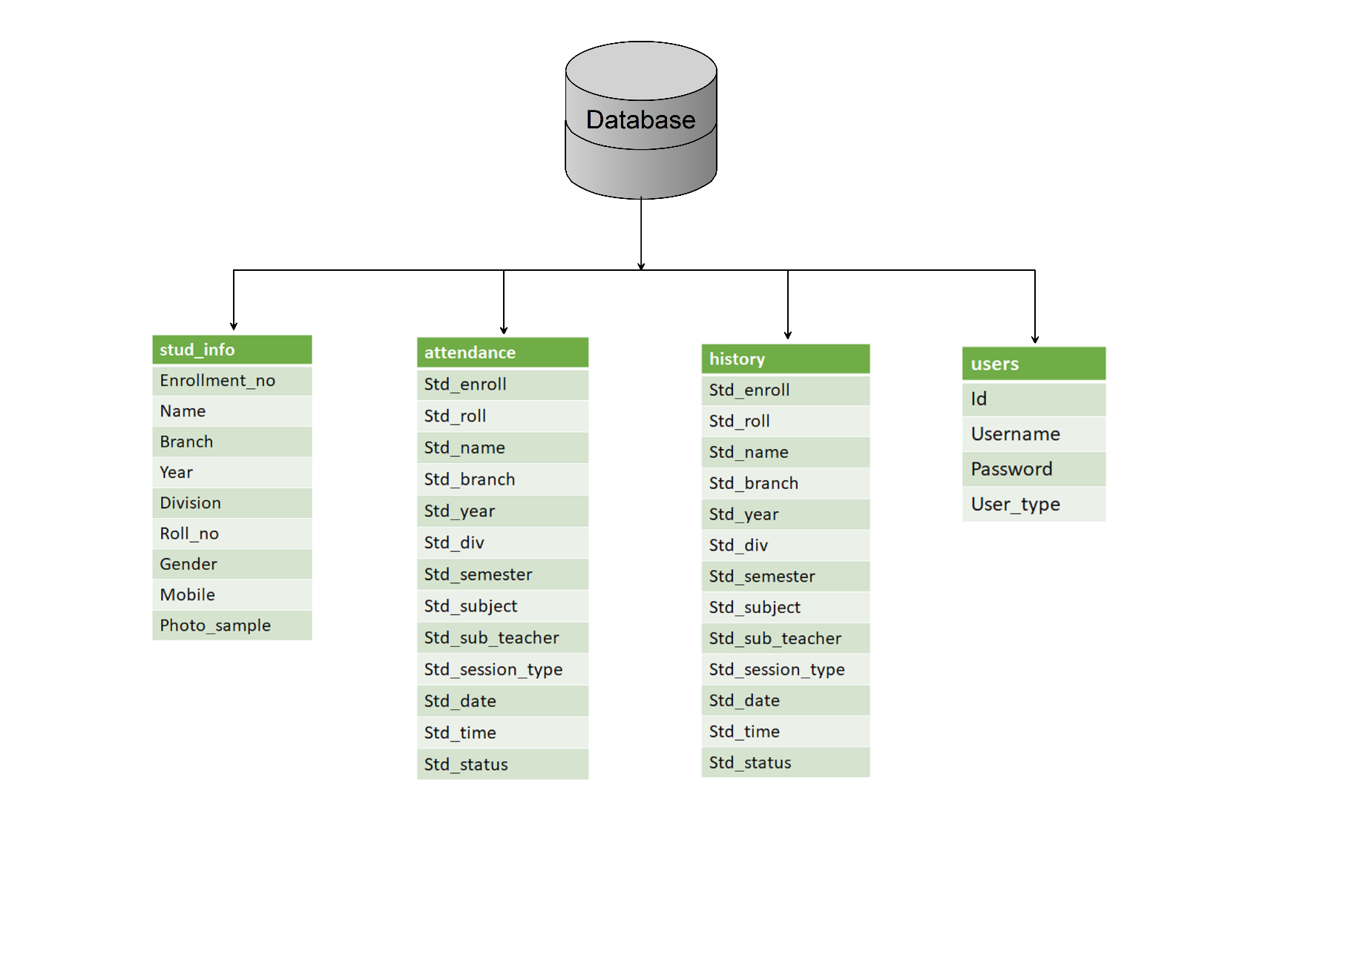

Fig 5.2 – Database Design

In (Fig 5.1) shows the Database Design

* The Database design contained 4 tables such as stud_info, attendance, history, users
* The stud_info table contain attribute such as enrollment no, name, branch, year, division, roll no, gender, mobile, photo sample
* The attendance table contain attribute such as enrollment no, roll no, name, branch, year, division, semester, subject, subject teacher, session type, date, time and attendance status
* The history table contain attribute such as enrollment no, roll no, name, branch, year, division, semester, subject, subject teacher, session type, date, time and attendance status
* The Users table contain attribute such as id, username, password and user type

**5.3. Admin Module Design**

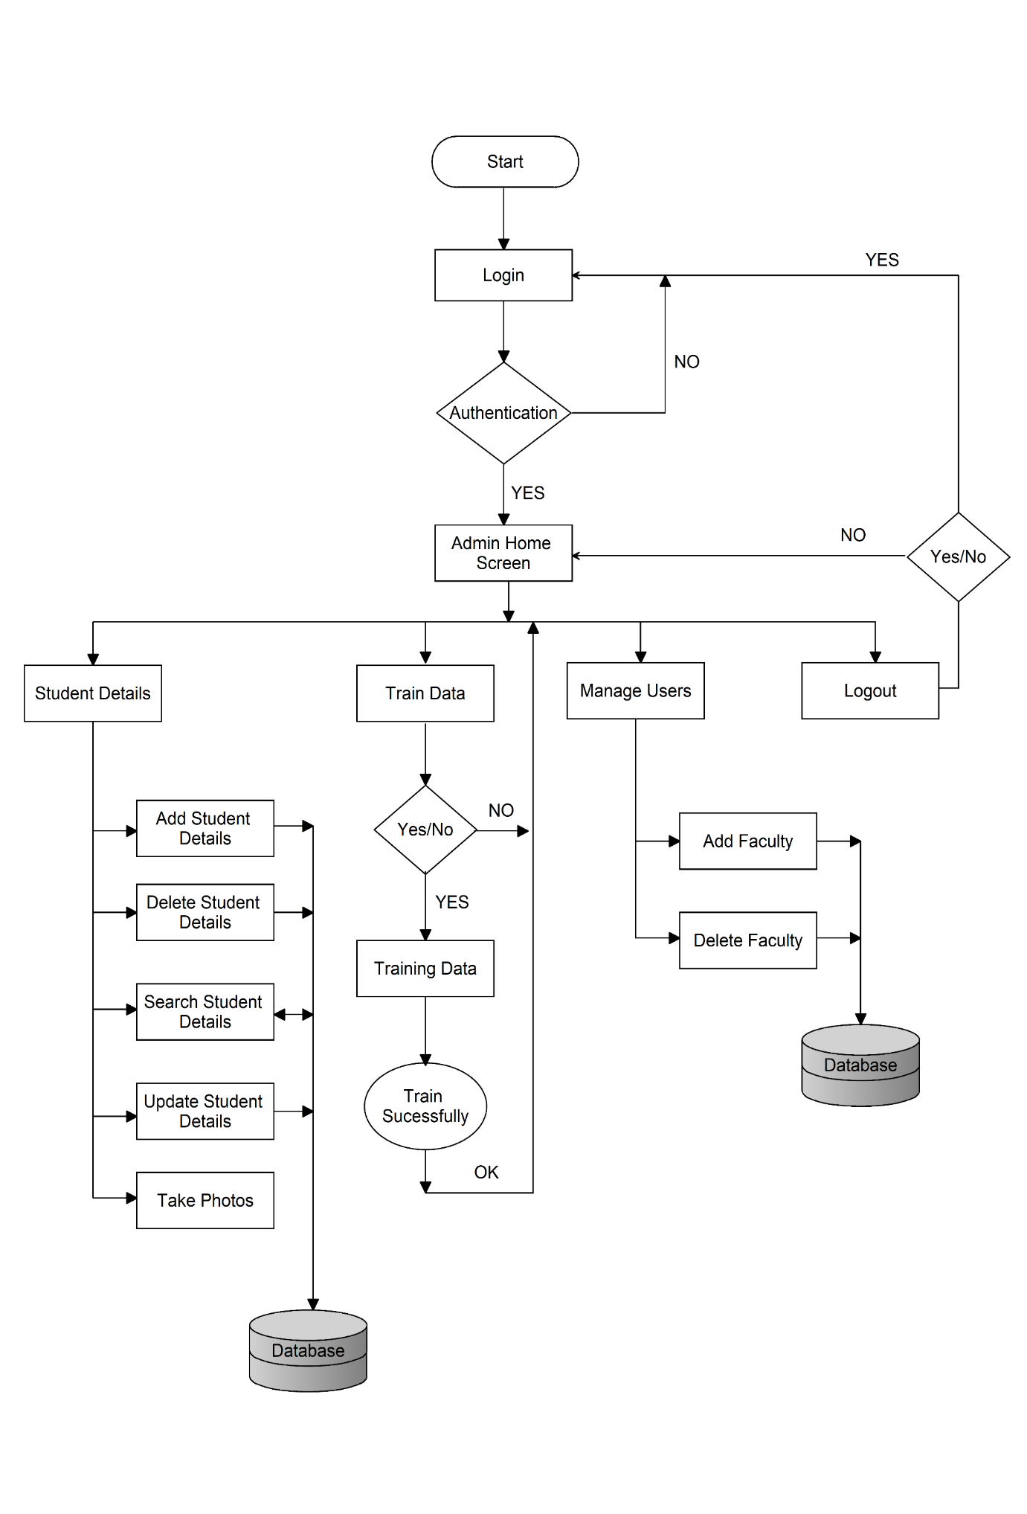

Fig. 5.3 - Admin Module Flowchart

Admin can Login in to Admin Dashboard to get access to different modules.

* Admin can insert data of new student or update the data of the existing student or can delete the record of the existing student available in Application
* Admin can search and check if the student’s data is stored or not by selecting his Branch, Year and Division to minimize duplication of student record after saving the data admin should select student information and Capture 100 photos of student using webcam and store it for recognition.
* Admin need to Train Data (creating .xml file by applying LBPH algorithm on students captured photos) after saving all students data.
* Admin can manage the Faculty Users.

**5.4 Faculty Module Design**

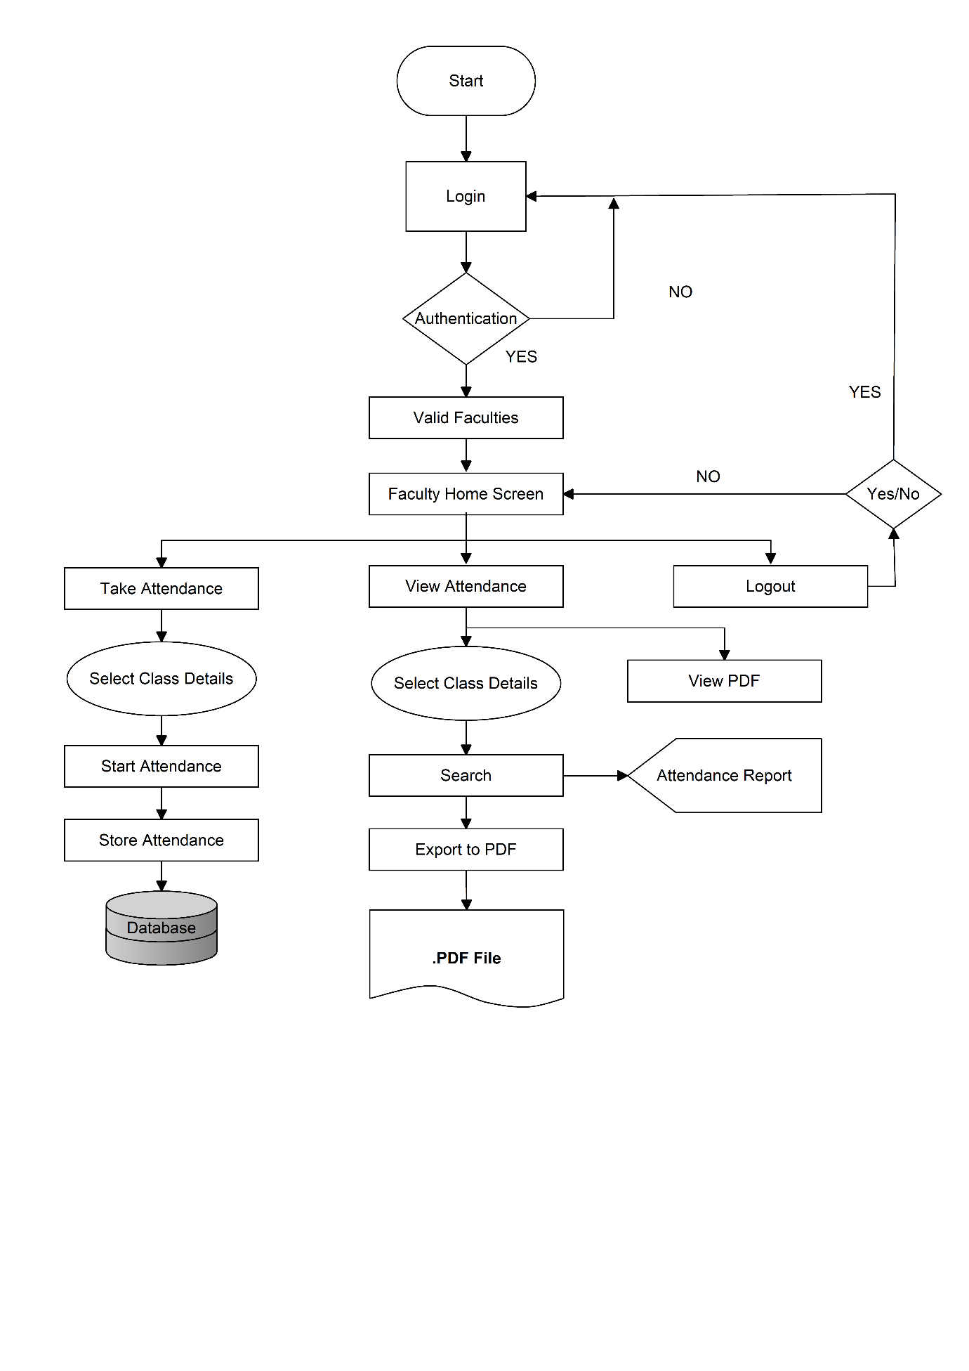

Fig. 5.4 - Faculty Module Flowchart

Faculty can Login in to Faculty Dashboard to get access to different modules.

* Faculty can Login in to Faculty Dashboard to get access to different modules.
* Faculty can Take Attendance of group of students by selecting their Branch, Year, Semester, Subject, Session Type and Division under the Faculty name.
* The attendance will be marked for 5 minutes after the attendance is marked in attendance table the attendance will be inserted in history table with students’ data either ‘Present’ or ‘Absent’ depending upon if the student has shown his face in front of the webcam.
* Faculty can view the history of attendance by searching through the student's Branch, Year, Semester, Subject, Session Type, Division and the Date of Attendance or by show all history of attendance, stored under the name.
* Faculty can also export the "searched attendance" of students in pdf format and view it.

**Chapter 6**

**Results and Applications**

**6.1 Results**

**6.1.1. Admin/Faculty Login**

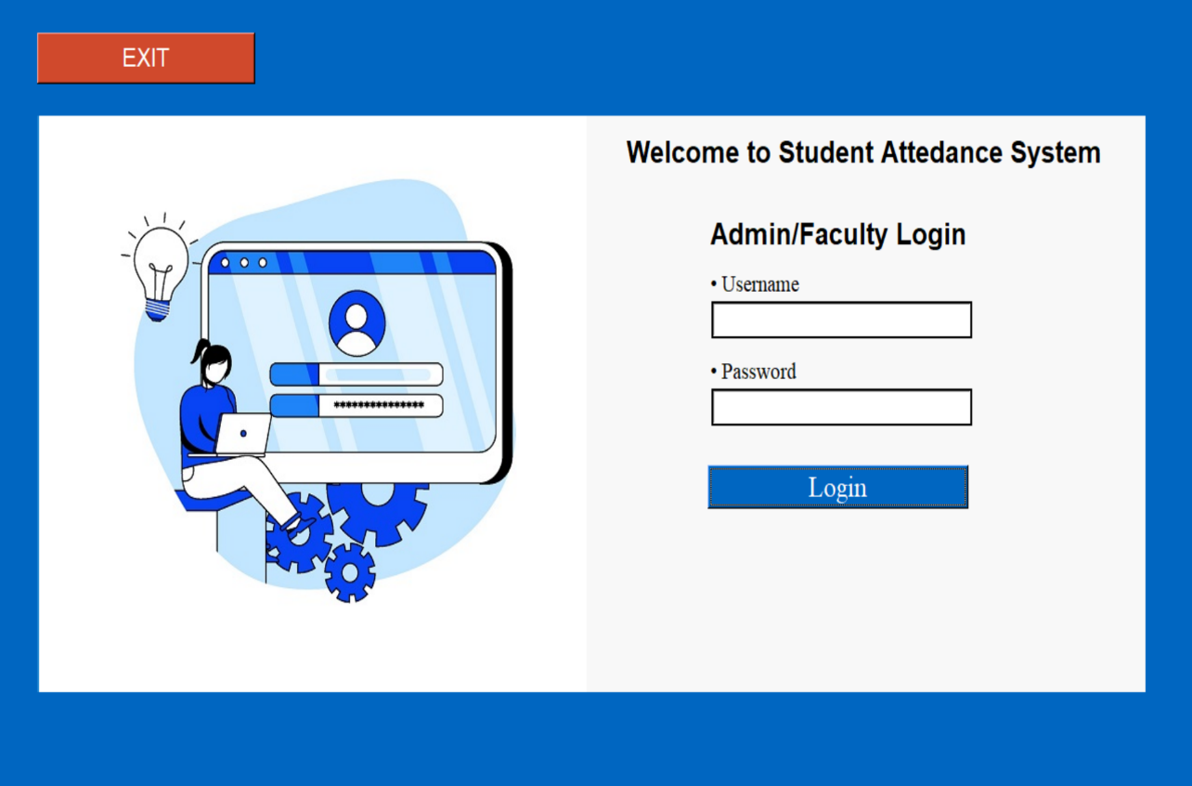

Fig. 6.1 – Login Screen

In (Fig. 6.1) display’s Login for Admin/Faculty.

* Both Faculty and Admin can login through this Login Module and then they can perform their role.
* Only the registered faculty can login through here.
* Faculty can be registered and unregistered by Admin.
* After Logging out both Admin and Faculty are redirected to this module.
* On click of Exit Button this system is closed.

**6.1.2. Admin Home Screen**

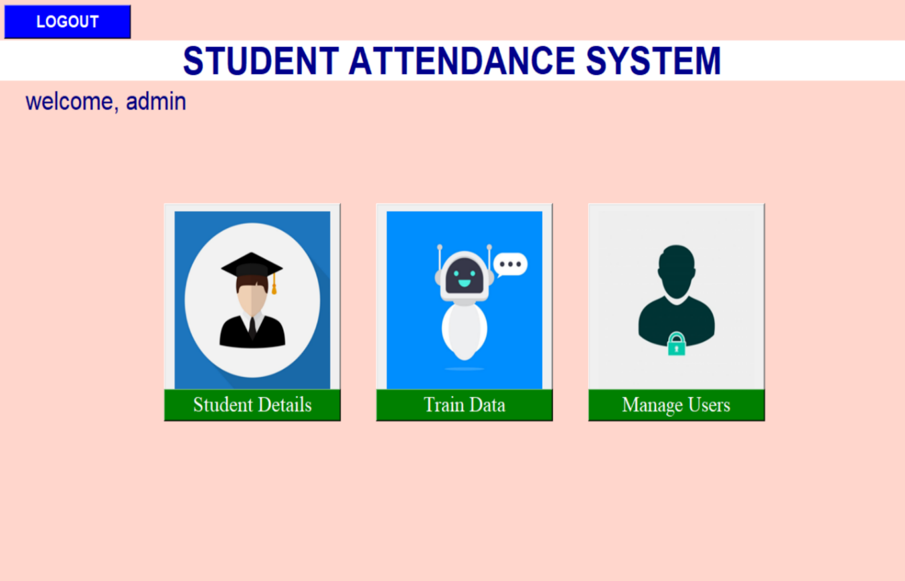

Fig. 6.2 – Admin Home Screen

In (Fig. 6.2) display’s Home screen of Admin.

In Home screen on click of a Student Details button admin is redirected to Student Details Module where admin can Manipulate Student data like add new student information, update a existing student information and also delete a student information.

In Home screen on click of Train Data button LBPH operation is performed to generate XML file of histograms of student images. It is necessary to Train Data after every changes made in Student Details (like delete student record or recapture new images or add new record with images) Admin need to manually click on Train Data button.

In Home Screen on click of Manage Users button Admin can register a faculty for taking attendance or unregistered the faculty as needed.

**6.1.3. Student Details**

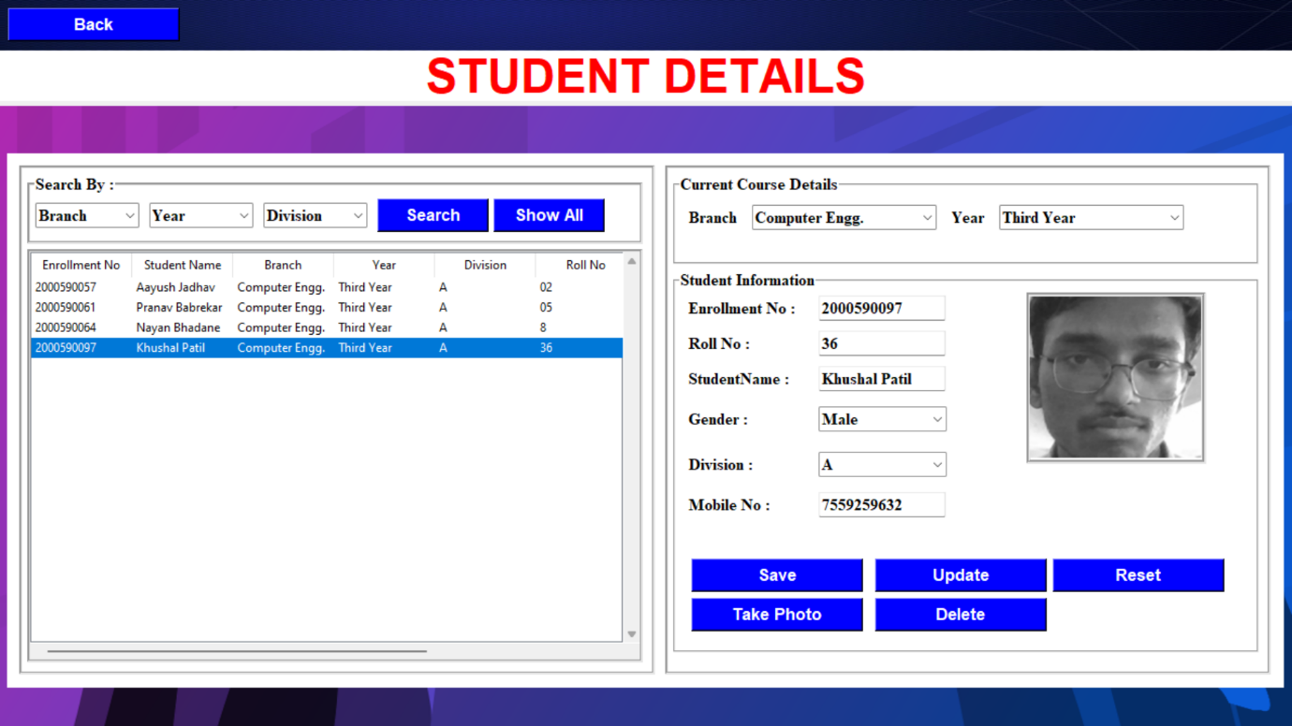

Fig. 6.3 - Student Details

In (Fig. 6.3) of Student Details

After filling required input fields, admin can add student record on click of Save button after record is successfully saved in database then the record is displayed in tabular format at left frame.

Admin can Search students record on the basis of Branch, Year and Division by selecting this fields from respective options on click of Search button, the result will be shown as per respective selection in tabular format at left frame.

Admin can also update a existing student record by selecting the particular record of a student from the tabular view, after filling upadated values in input fields then the record can be updated on the click of Update button.

Admin can also delete an existing student record by selecting the particular record of a student from the tabular view, then the record can be deleted on the click of Delete button.

**6.1.4. Capturing Student Images**

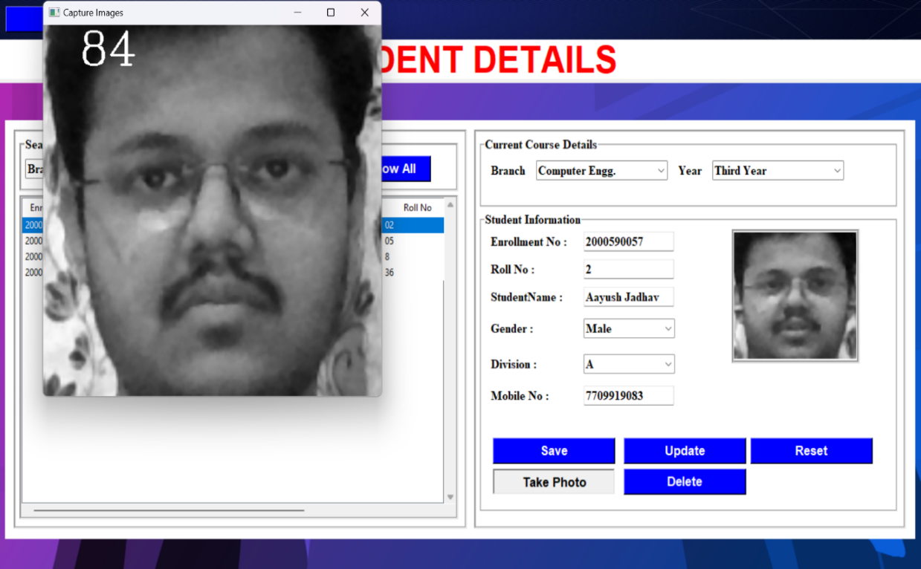

Fig. 6.4 - Capturing Student Images

In (Fig. 6.4) of Student Details

Admin can capture images of student by facing the webcam to the respective student (whose record is selected) before clicking on ‘Take Photo’ button, the image will be captured only if the student record exists in database.

The Images of a respective student will be saved in ‘student.Enrollment_No.N’ format, here ‘Enrollment_No’ is Unique key and ‘N’ represents number of image from 1 to 100.

The System will capture 100 images of a student on delay of 250ms as per image capture. After capturing of 100 images is completed a message will be displayed ‘Images are Captured Successfully’

**6.1.5. Manage Users**

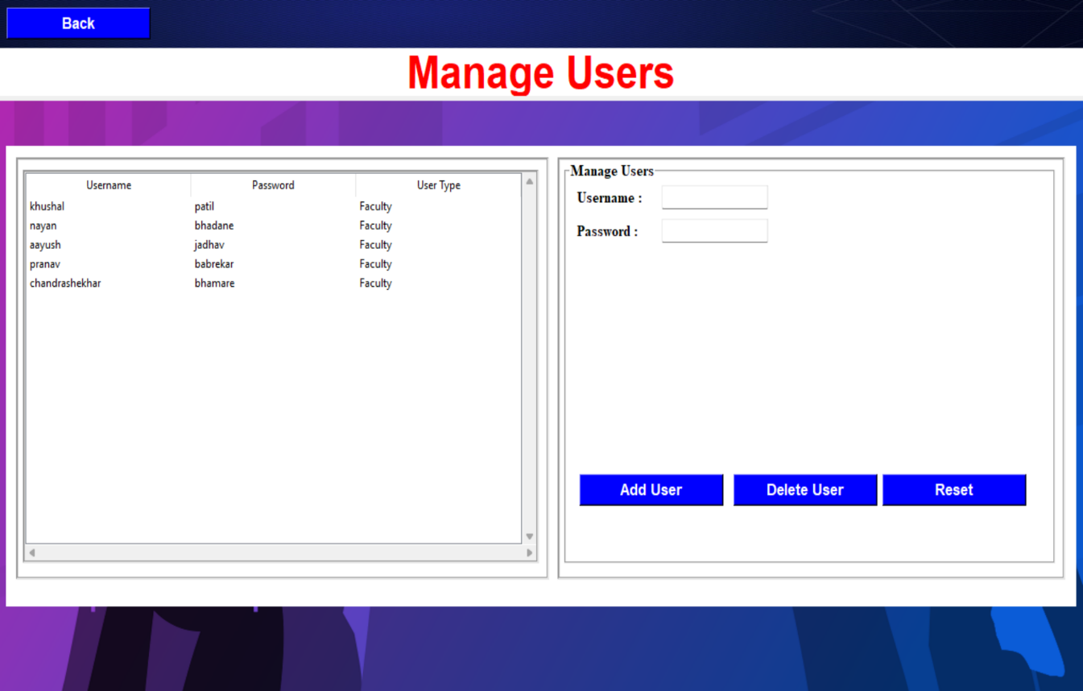

Fig. 6.5 - Manage Users

In (Fig. 6.5) of Manage Users

Admin can register and unregister user (‘user’ as a Faculty) as required on click of Add User and Delete User buttons respectively.

**6.1.6. Training Dataset Images**

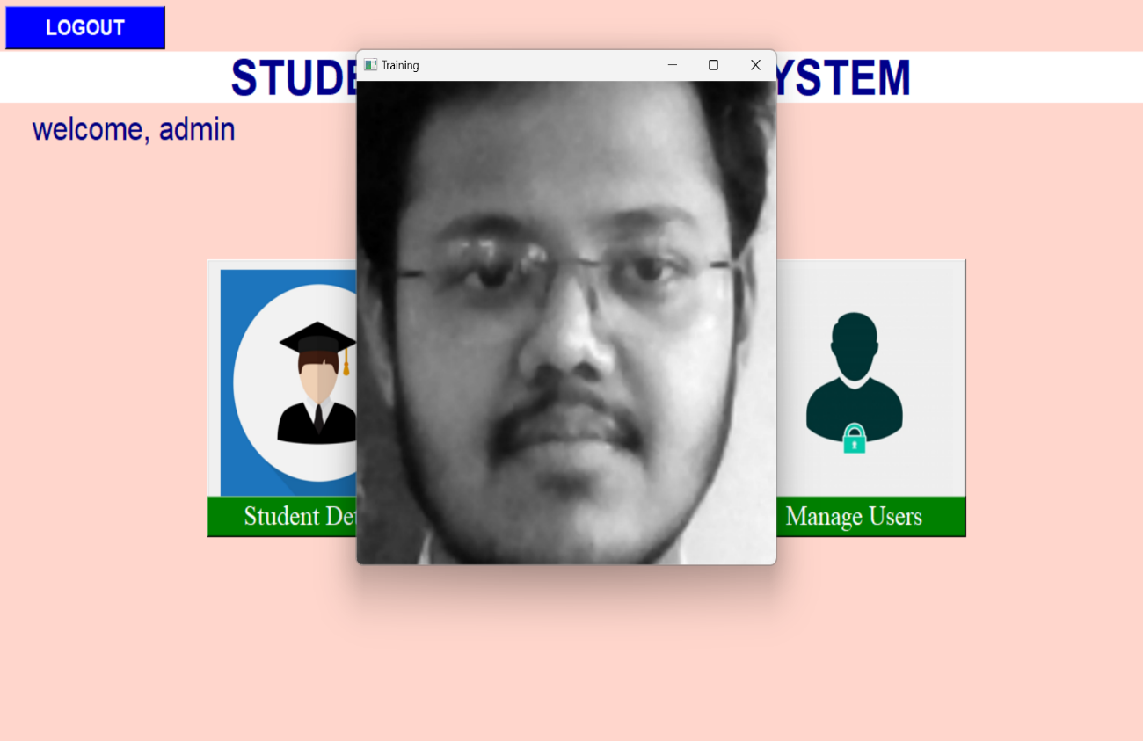

Fig 6.6 - Training Dataset Images

In (Fig. 6.6) the students data is trained on click of ‘Train Data’ button available on Admin Home screen.

After the data is trained a message is displayed about the ‘Training Dataset Completed’.

**6.1.7. Faculty Home Screen**

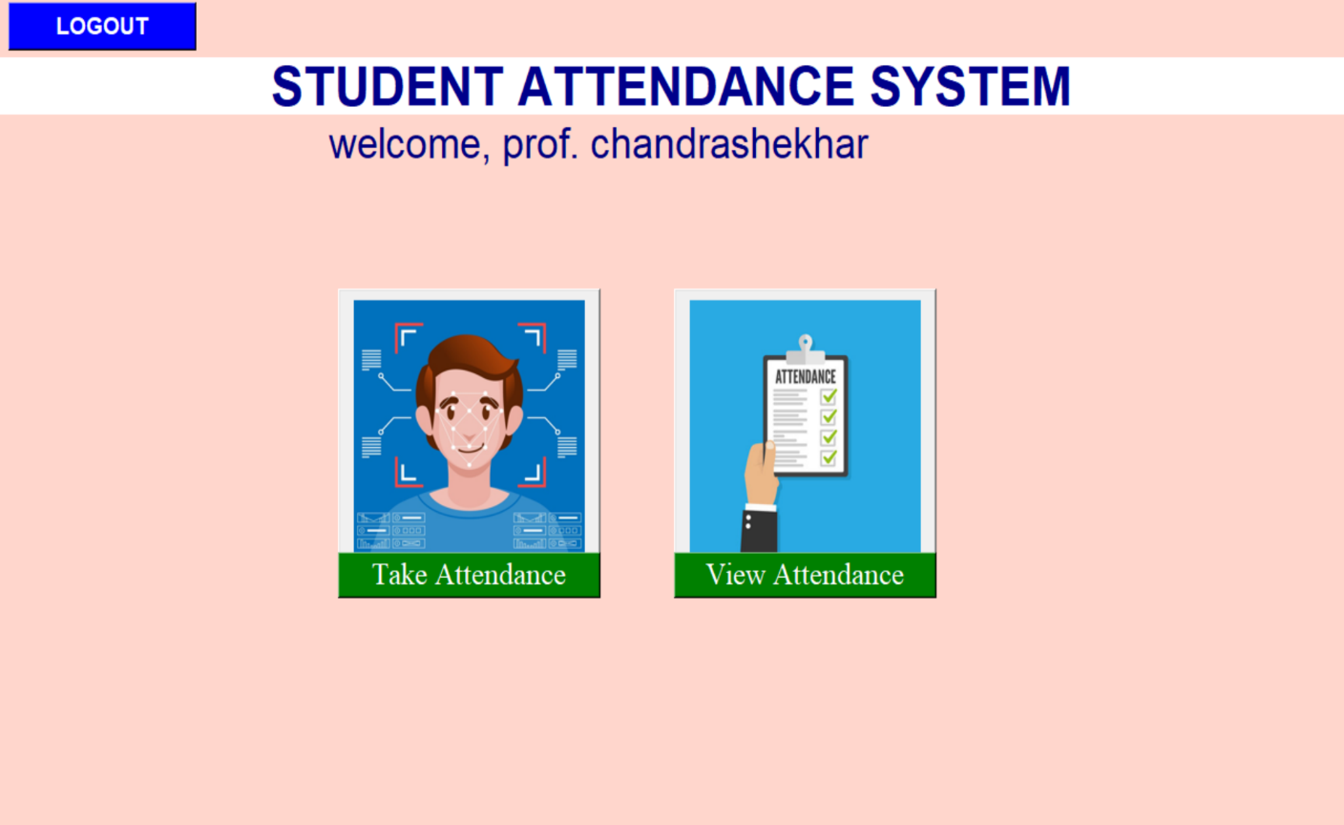

Fig. 6.7 - Faculty Home Screen

In (Fig. 6.8) display’s Home screen of Faculty.

In Home screen Faculty can Take Attendance and View Attendance of student under his Username.

**6.1.8. Take Attendance**

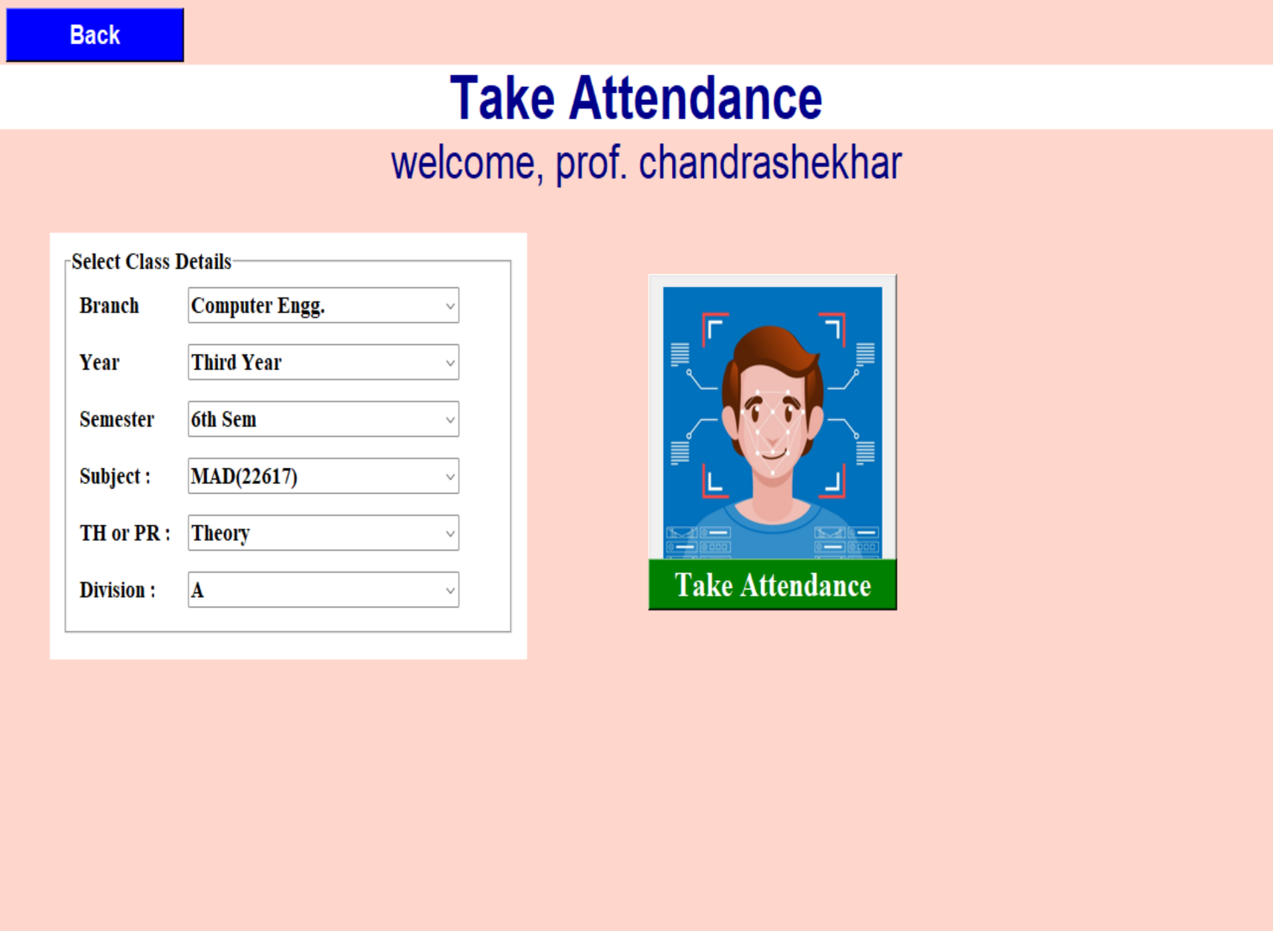

Fig. 6.8 - Take Attendance Screen

In (Fig. 6.9) of Take Attendance Screen

Faculty need to select class details like (Branch, Year, Semester, Subject, Session type and Division) for taking attendance of a selected class after clicking on Take Attendance button.

**6.1.9. Attendance Marking**

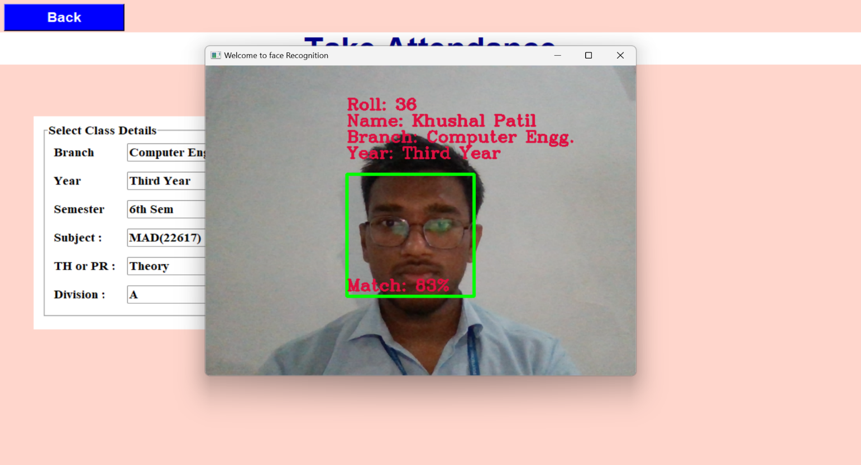

Fig. 6.9 - Attendance Marking

In (Fig. 6.9) of Attendance Marking

The student recognized is encircled with rectangle and the details of that student is shown on the screen.

If the details selected of class match with the class details of the recognized student a ‘Present’ sound is played and his attendance is marked in database table.

If the record of the student is not present with his/her trained images in the system it will encircle the respective student face with rectangle and display ‘Unknown Face’.

**6.1.10 View Attendance**

## 

Fig 6.10 - View Attendance

In (Fig. 6.10) of View Attendance

If faculty clicks on ‘Show All’ button the whole attendance record stored under the faculty name is displayed in tabular format.

**6.1.11. Searched Attendance History**

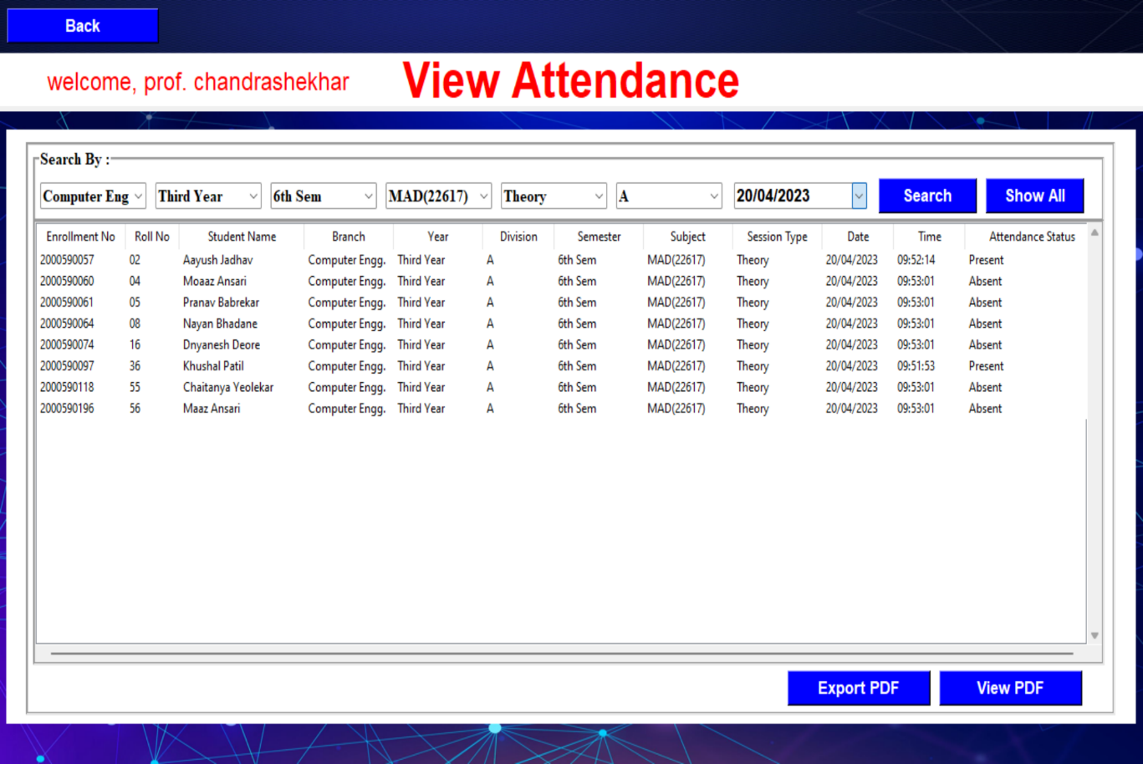

Fig. 6.11 - Searched Attendance History

In (Fig. 6.11) Searched Attendance History

the faculty can search attendance record of particular class by clicking ‘search’ button, after selecting options present in search by like (Branch, Year, Semester, Subject, Session type and Division) then the students record will be displayed in tabular format on screen of that searched class respectively.

**6.1.12. Attendance PDF Report**

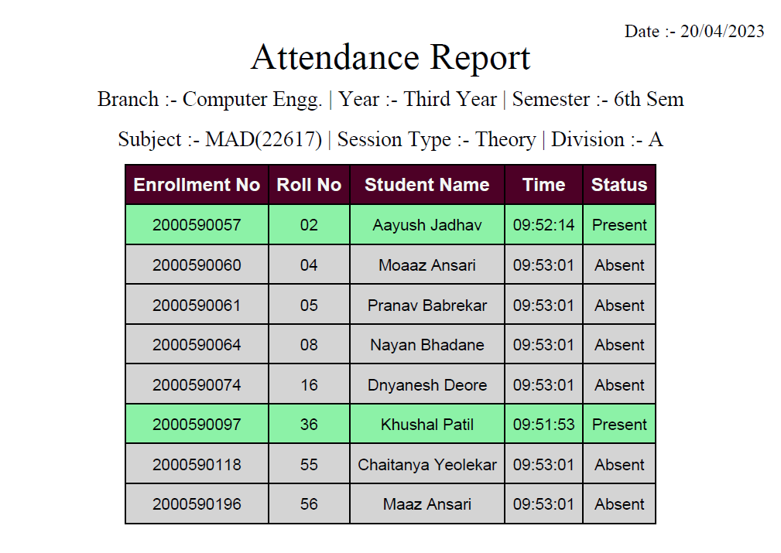

Fig. 6.12 – Attendance PDF Report

In (Fig. 6.12) Attendance PDF Report

Faculty can also export the searched attendance report in PDF format on click of Export PDF button a File Dialog Box will be prompted and the faculty can store the attendance report as per the requirement.

The output of the exported attendance report in classic attendance report format and the Present Students Record will be shown as highlighted in Green Background.

**6.2 Applications**

This project can be used for marking theory and practical attendance of Students

**Chapter 7**

**Conclusions and Future Scope**

**7.1 Conclusion**

We have implemented Face Recognition using Haar Cascade and LBPH AlgorithmFor student’s attendance. It helps to reduce time and effort, especially in the case of large number of students marked attendance.

The whole system is implemented in Python programming language, LBPH is one of the prominent techniques for face recognition. Our system successfully recognizes a student with unintentional changes like wearing glasses or growing beard able to identify the faces of students with an accuracy rate up to 90%. The clear image and correct pose may increase the face recognition accuracy.

Here the problem is the dataset is small and is affected by the lighting and background in data collection and testing training directly compared to other contacted method, e.g., fingerprint. Face recognition is safer from spreading infectious disease than the contacted method, e.g., fingerprint, signing, etc.

**7.2 Future Scope**

* In future, an effort could be made to build a better dataset that might practically give a more accurate result. We can improve haar cascade classifiers through the synthesis of new training examples which can improve the recognition rate of unknown persons.
* A system alert (voice and visual) can be included if an intruder is detected in the class.
* On this project, there is some further works to do for alert the student by sending SMS regarding his, her attendance. GSM module is used for this purpose. Parent of the student gets this SMS alert.

**References and Bibliography**

[1] Bharat T. Chinimilli, Anjali T, Akhil Kotturi, Vihas R. Kaipu, Jathin Varma Mandapati, “Face Recognition based Attendance System using Haar Cascade and Local Binary Pattern Histogram Algorithm”, (2020)

[2] Ononiwu G. Chiagozie, Okorafor G. Nwaji, “Radio-frequency identification (RFID) based Attendance System with Automatic Door Unit”, Academic Research International (2012).

[3] O. Shoewu, PhD, O.A. Idowu, B.Sc., “Development of Attendance Management System using Biometrics.” The Pacific Journal of Science and Technology (2012).

[4] Jomon Joseph1, K. P. Zacharia, “Automatic Attendance Management System Using Face Recognition”, International Journal of Science and Research (IJSR), 2013.